DOM Document Object Model
- The DOM represents the document as nodes and objects
  - That way, the programming languages can connect to the page
- DOM is a standard of how to:
    - Get HTML element
    - Change HTML element
    - Add HTML element
    - Delete HTML element

HTML DOM
- The HTML DOM is an Object Model for HTML. It defines:
  - HTML elements as objects
  - Properties for all HTML elements
  - Methods for all HTML elements
  - Events for all HTML elements

DOM Methods

  - DOM Methods - actions you can perform on HTML
elements
  - DOM Properties - values of HTML elements that you can
set or change

Example: DOM Methods

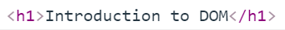
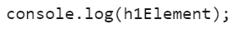
- HTML DOM method is an action you can do (like add or delete an HTML element) 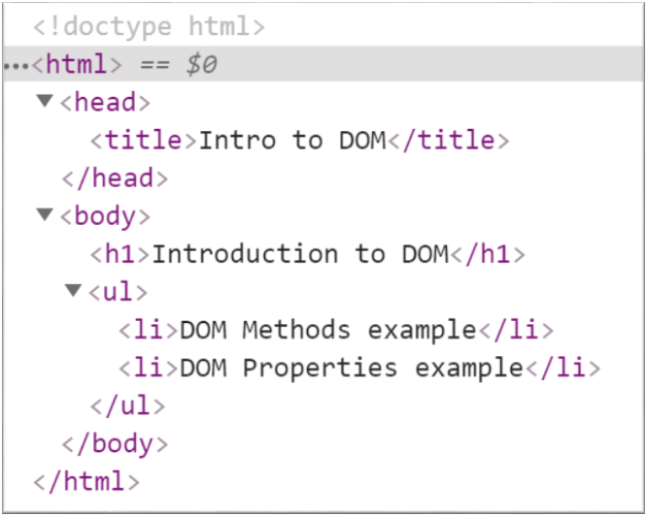

Example: DOM Methods
- HTML DOM property is a value that you can get or set (changing the content of an HTML element)
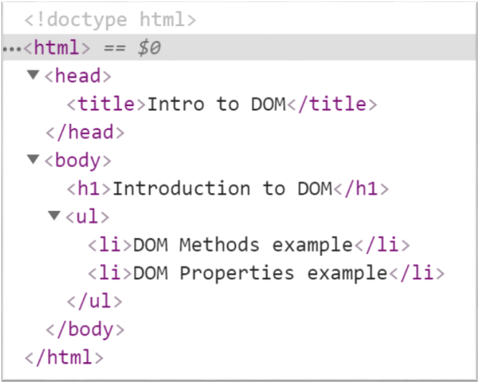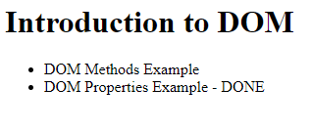

DOM Manipulations --- Modify the DOM Tree
Selection of Elements
- There are a few ways to find a certain HTML element in the DOM:
  - By id - getElementById()
  - By tag name - getElementsByTagName()
  - By class name - getElementsByClassName()
  - By CSS selector - querySelector()
CSS Selectors
- CSS selectors are strings that follow CSS syntax for matching
- They allow very fast and powerful element matching, e.g.:
  - "#main" - returns the element with ID "main"
  - "#content div" - selects all <div>s inside #content
  - ".note, .alert" - all elements with class "note" or "alert"
  - "input[name='login']" - <input> with name "login"

DOM Manipulations
- The HTML DOM allows JavaScript to change the
content of HTML elements
  - innerHTML
  - attributes
  - setAttribute()
  - style.property
- We can create, append and remove HTML elements
dynamically
  - removeChild()
  - appendChild()
  - replaceChild()
  - document.write()

Creating DOM Elements
- Creating a new DOM element
let p = document.createElement("p");
let li = document.createElement("li");

- Create a copy / cloning DOM element
let li = document.getElementById("my-list");
let newLi = li.cloneNode(true);

- The above code creates a new elements. But these elements
don't exist anywhere except as values inside variables.

Deleting DOM Elements
<div id="div1">
<p id="p1">This is a paragraph.</p>
<p id="p2">This is another paragraph.</p>
</div>

let parent = document.getElementById("div1");
let firstChild = document.getElementById("p1");
let secondChild = document.getElementById("p2");
firstChild.remove(); Directly deleting
parent.removeChild(secondChild); Deleting by parent element

Creating DOM Elements
let list = document.createElement("ul");
let firstLi = document.createElement("li");
firstLi.textContent = "Peter";
list.appendChild(firstLi);
let secondLi = document.createElement("li");
secondLi.innerHTML = "<b>Maria</b>";
list.appendChild(secondLi);
document.body.appendChild(list);
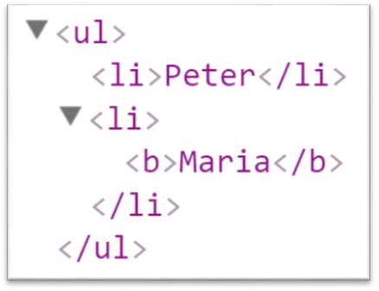

DOM Properties and HTML Attributes: Properties vs. Attributes
  - Attributes are defined by HTML. Properties are defined by the DOM
  - Attributes initialize DOM properties
    - Property values can change
    - Attribute values can't
  - The HTML attribute and the DOM property are not the
same thing, even when they have the same name
DOM Properties
- textContent - reads and writes text
let text = Node.textContent;
Node.textContent = 'New text for element.';

- innerHTML - returns and writes the HTML of a given element
let html = myElement.innerHTML;
myElement.innerHTML = 'New text for element.';

- value - gets and sets value
let theValue = theFormField.value;
theFormField.value = 'New value';

HTML Attributes and Methods
setAttribute() - sets the value of an attribute on the specified HTML element
<input type="text" name="username"/>
<input type="password" name="password"/>

const inputPassEle = document.getElementsByTagName('input')[1];
inputPassEle.setAttribute('name', 'password');
HTML Attributes and Methods
removeAttribute() - removes the attribute with the specified name from an HTML element
<input type="text" name="username" placeholder="Username..."/>
<input type="password" name="password" placeholder="Password..."/>

const inputPassEle = document.getElementsByTagName('input')[1];
inputPassEle.removeAttribute('placeholder');

hasAttribute() - method returns true if the specified attribute exists, otherwise it returns false
<input type="text" name="username" placeholder="Username..."/>
<input type="password" name="password" id="password"/>

const passwordElement = document.getElementById(password');
passwordElement.hasAttribute('name'); // true
passwordElement.hasAttribute('placeholder'); // false

classList - is a read-only property that returns a collection of the class attributes of specified element
<div class="container div root"></div>
const element = document.getElementById('myDiv').classList;
// DOMTokenList(3)
["container", "div", "root", value: "container div root"]

classList Methods
<div class="container div root"></div>
- add() - Adds the specified class values
document.getElementById('myDiv').classList.add('testClass');
- remove() - Removes the specified class values
document.getElementById('myDiv').classList.remove('container');

Parents and Child Elements
Every DOM Elements has a parent
- Parents can be accessed by keywords .parent or .parentNode
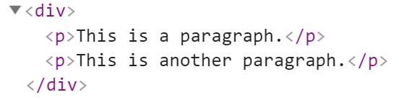

let firstP = document.getElementsByTagName('p')[0];
console.log(firstP.parent); - Accessing the child parent

- When some element contains other elements, that means he is parent of this elements
- Also this elements is children to the parent. They can be accessed by keyword .children
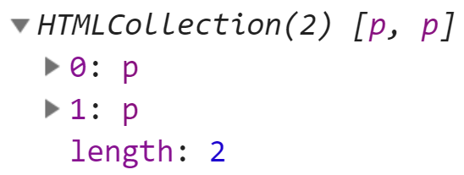
let pElements = document.getElementsByTagName('div')[0].children; -Returns HTML Collection

- firstElementChild - Returns the first child node of an element
- lastElementChild - Returns the last child node of an element

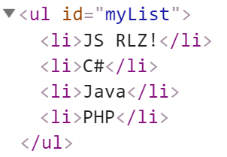 let list = document.getElementById('myList');

list.firstElementChild; 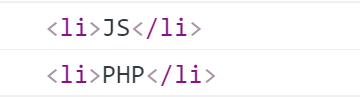
list.lastElementChild;

list.firstElementChild.textContent += " RLZ!";

- nextElementSibling - Returns the next node at the same node tree level
- previousElementSibling - Returns the previous node at the same node tree level
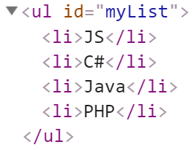
let ul = document.getElementById('myList');
let next = ul.children[0].nextElementSibling;
console.log(next.textContent); // C#
let prev = next.previousElementSibling;
console.log(prev.textContent); // JS

- appendChild - Adds a new child, as the last child
let p = document.createElement("p");
let li = document.createElement("li");
li.appendChild(p);

- prepend - Adds a new child, as the first child

let ul = document.getElementById("my-list");
let li = document.createElement("li");
ul.prepend(li);

NodeList vs. HTMLCollection
- Both interfaces are collections of DOM nodes
- NodeList can contain any node type
- HTMLCollection is supposed to only contain Element nodes
- An HTMLCollection provides the same methods as a NodeList
and additionally a method called namedItem

DOM Events - handling
- Events are actions or occurrences
- They allow JavaScript to register different event handlers on elements
- Events are normally used in combination with functions, and the function will not be executed before the event occurs
htmlRef.addEventListener( 'click' , handler );

Browser Object Model (BOM)
- Browsers expose some objects like window, screen, navigator, history, location, document, …
- console.dir(window); console.dir(navigator); console.dir(screen); console.dir(location);
- console.dir(history); console.dir(document);

Playing with BOM
alert(window.navigator.userAgent);
console.log(navigator.language); // en-US
console.log(screen.width + " x " + screen.height); // 1920 x 1080
document.location = "https://softuni.bg";
history.back();

